The following discrepancies in the Daily Progress Report (DPR) generated via T-Code ZPRA_Reports
- Graph Plot Error: There is a technical error in the production performance graph comparing Actual Production vs. BE Target. The table below is showing correct.
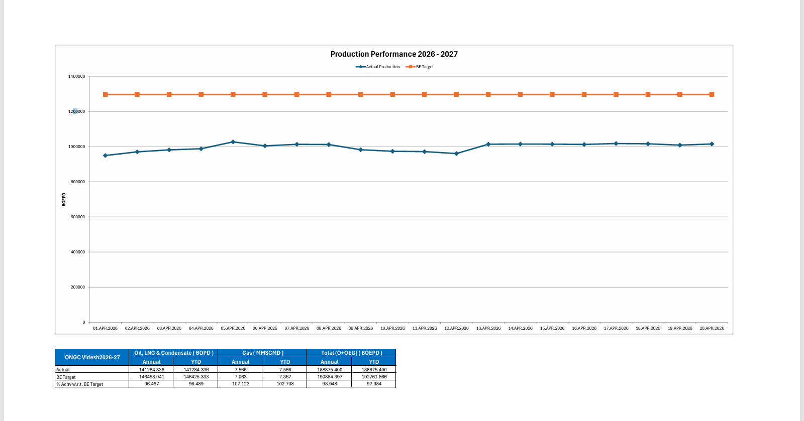
2. Production Data Mismatch (Block 6.1): For Project Block 6.1, the total O+OEG production for FY 2025-26 is reflected incorrectly in the DPR. The accurate data is available in the Reconciled Production reports, as referenced below

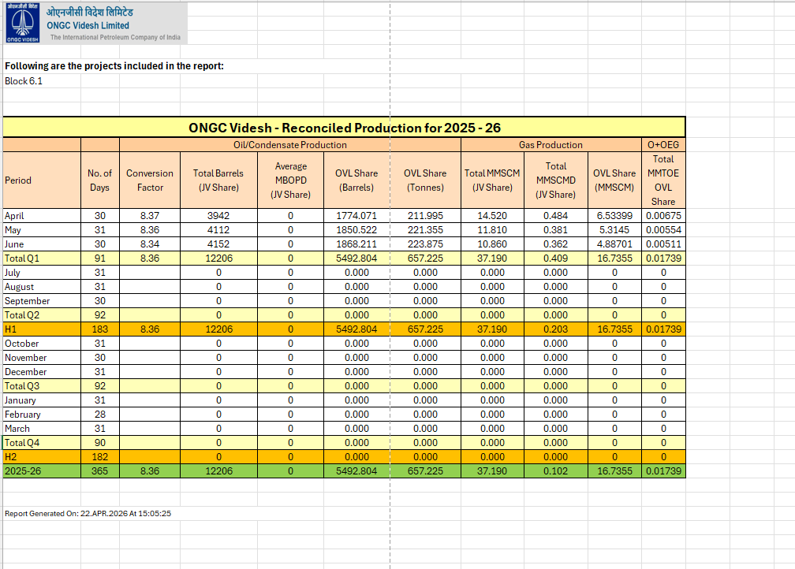
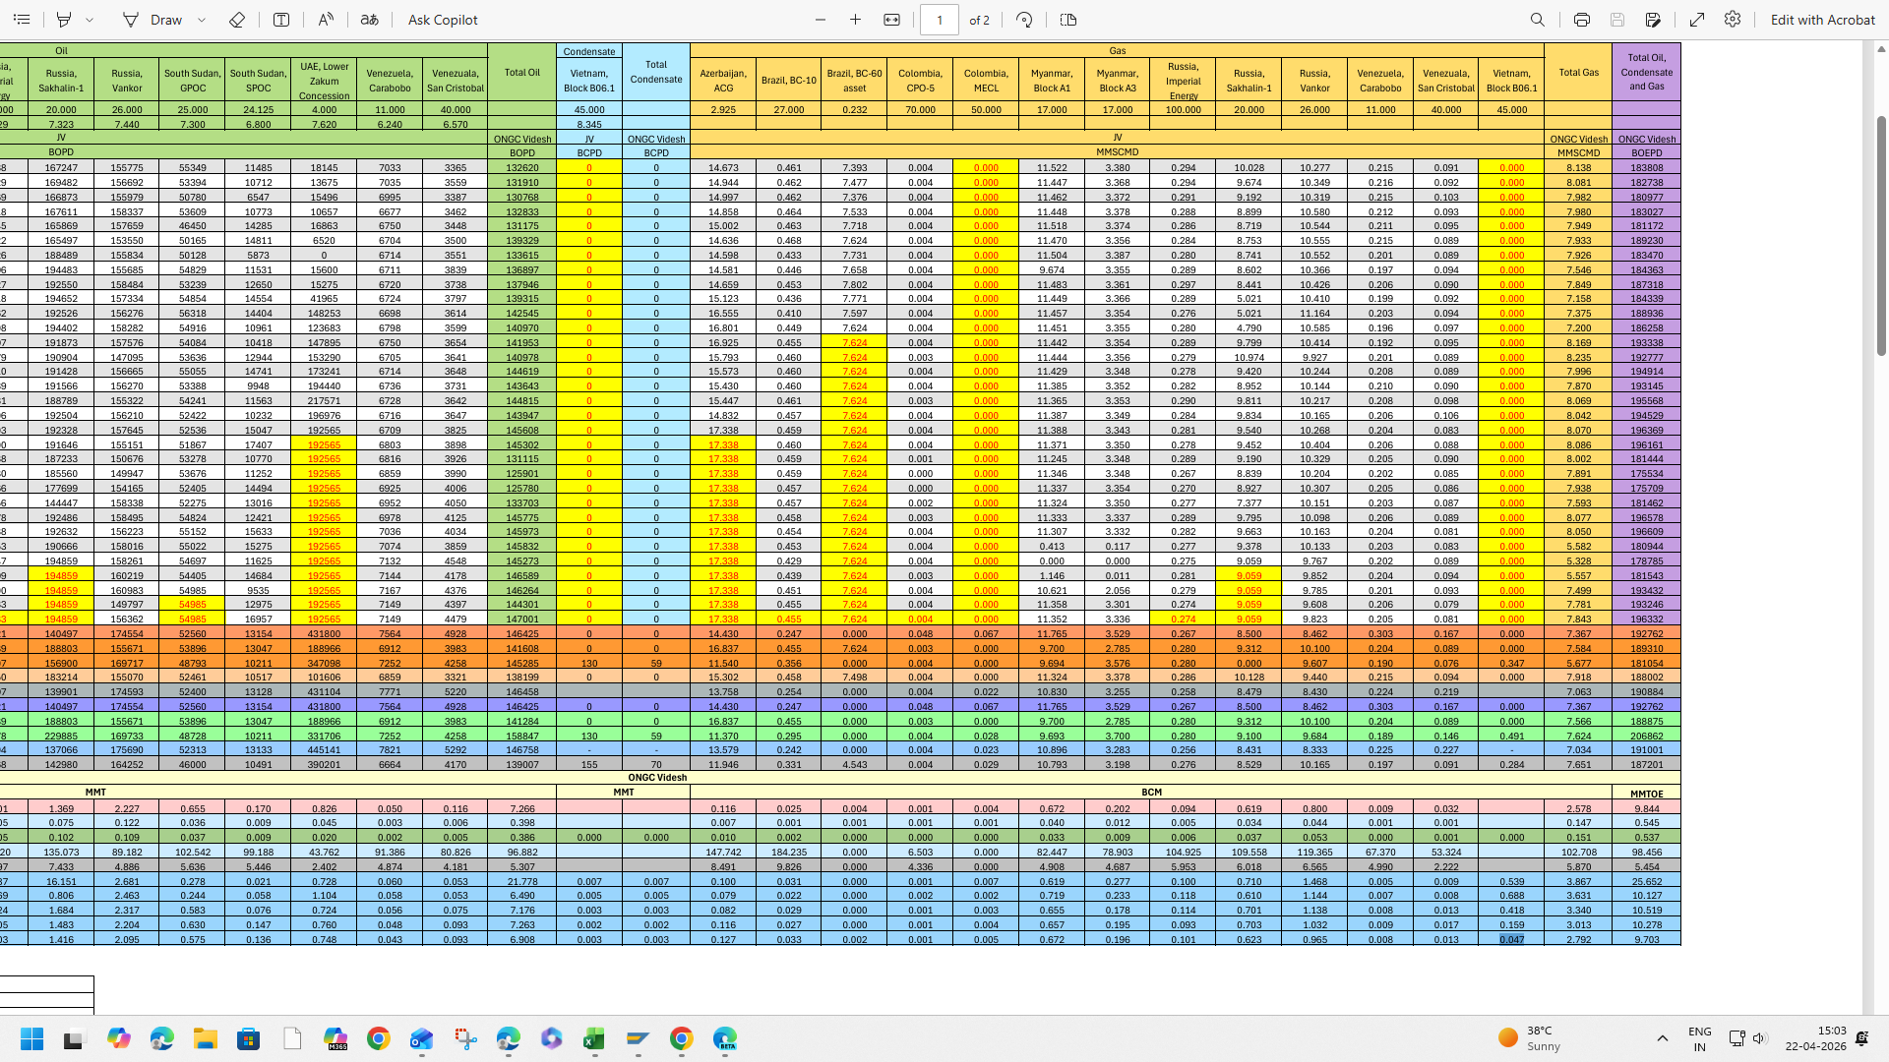

3. Missing Target Values (Project BC-60): In the JV BOPD and JV MMSCMD column, the following fields are not populating data:
- Target: April 2026
- Target: 2026–27
- YTD Target: 2026–27
- YTD Actual Prod.
- Asking Rate: 2026–27
Note: The target values in MMT/BCM are displayed correctly.
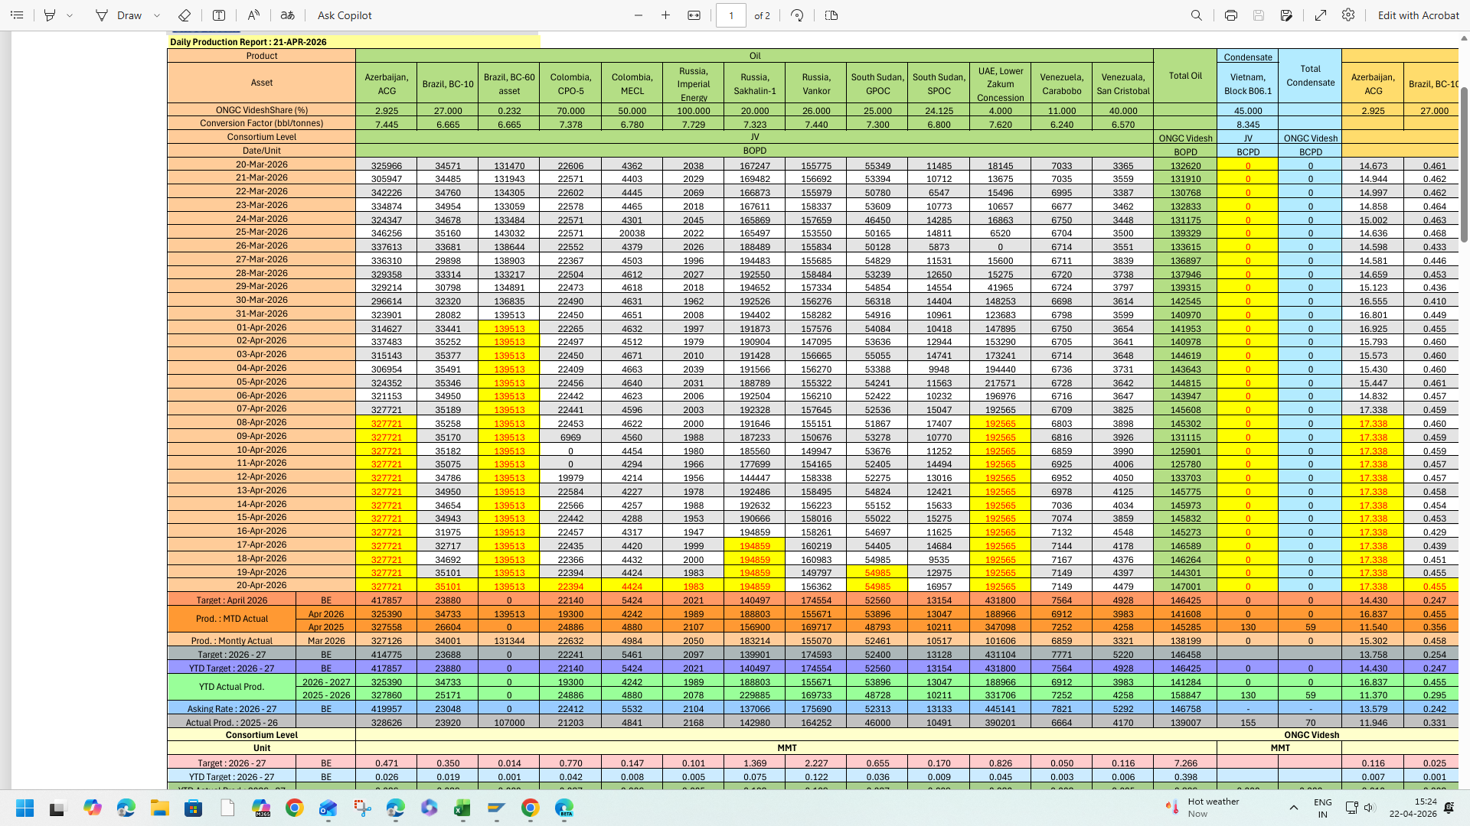
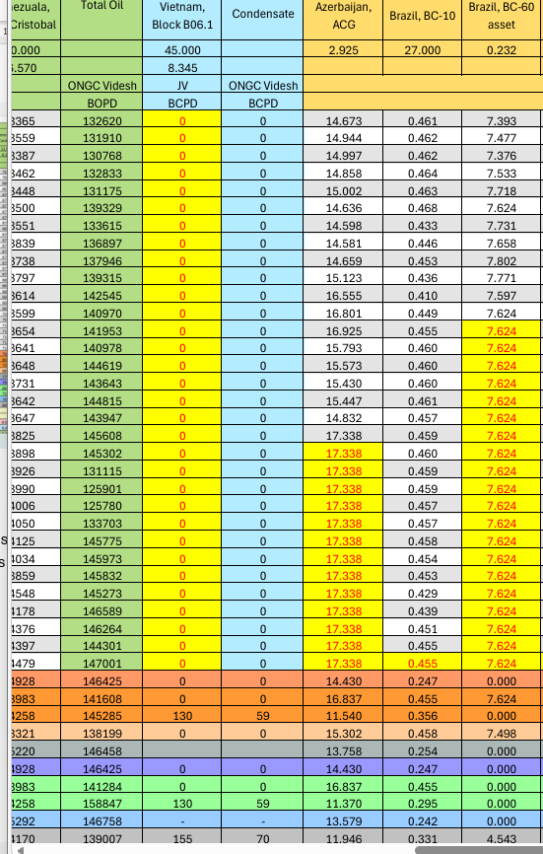

4. Historical Data Error (Sakhalin-1): The actual production figures for FY 2020-21 for Sakhalin-1 are incorrect in the generated DPR. The verified figures can be found under ZPRA_Reports -> Production in Last Five Years Reports.

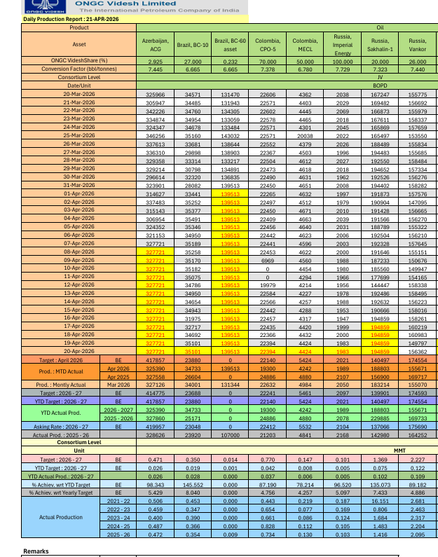
Correct figures are available and shown under ZPRA_reports -> Production in last five years reports
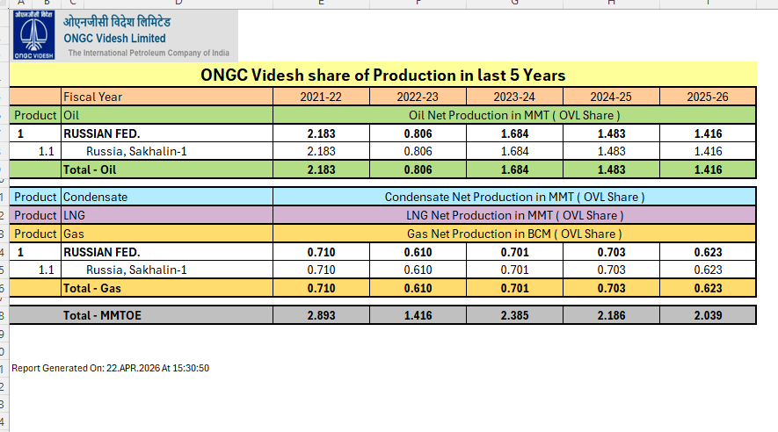
5. Character limit increase in comment for Daily production: Under (T-Code ZPRA_BU) the Daily Production Reporting section, the current character limit for the "Comments" field is insufficient. We request that this limit be increased to allow for more detailed technical descriptions.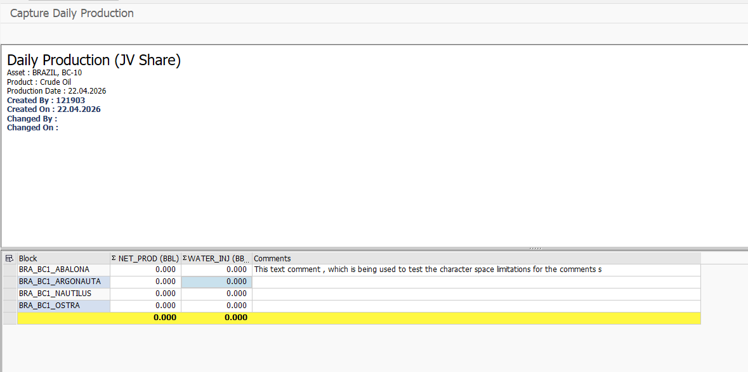
6. Approval Tracking (Monthly Reconciled Production): Currently, the Maintain Monthly Reconciled Production screen ( ZPRA_BU -> monthly transaction -> maintain monthly reconciled production) displays Created By, Created On, Changed By, and Changed On. It is suggested that the fields Approved By and Approved On be added to the display
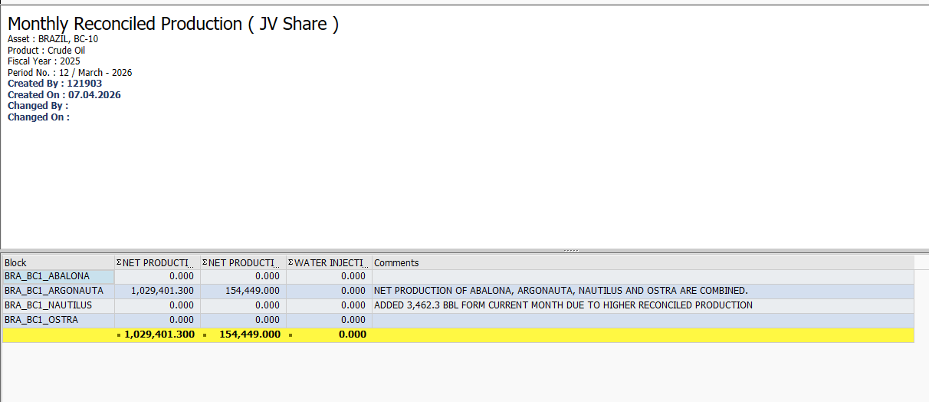
7. Regarding the Maintain Well Status section under Daily Transactions (T-Code: ZPRA_BU) –
Current Issue: The system currently generates a blank document for each new daily entry. This requires users to manually re-enter or copy-paste recurring information from previous days, which is inefficient and prone to errors.
Requested Enhancement: We request that the system be configured to auto-populate the Word/Doc file with the content from the most recent entry. Instead of starting with a fresh sheet, users should be able to simply update the existing status from the previous date.

